iPhone App Specification

# Introduction

The website under development is [www.how-late.com](http://www.how-late.com). The site is aimed at medical clinics. It allows clinics to inform patients how late a particular appointment is running that day.

This document is for an iPhone App which allows patients to quickly determine whether their doctors appointment is running late. For each clinic and doctor that they have registered for, a lateness is displayed. This is refreshed when the app is launched, and also from a refresh button within the app.

It is essential that all communications between the app and the website is via a well-defined API.

# Application Programming Interface

A PHP-based website exists at <http://how-late.com/api.php> and this is partially written.

The API methods documented here may undergo signature changes and additions. Right now the API methods which are relevant to the iPhone App are:

|  |  |  |
| --- | --- | --- |
| Method | Purpose | Examples |
| get | Done on refresh. Returns json of clinics and within the clinics, the lateness of doctor(s). Only the doctors the patient has registered for are displayed. | <http://www.how-late.com/api.php?id=id&met=get&ver=1.0&pin=AAABB> |
| help | Returns html (to be displayed in a modal window) | <http://www.how-late.com/api.php?id=id&met=help&ver=1.0&pin=AAABB> |
| reg | Registers a smartphone device to receive updates for a certain practitioner. This registration is stored at the server. | <http://www.how-late.com/api.php?id=id&met=reg&ver=1.0&pin=AAABBA> |
| dereg | Deregister a smartphone device to receive updates for a certain practitioner. This deregistration updates the server db. | <http://www.how-late.com/api.php?id=id&met=dereg&ver=1.0&pin=AAABBA> |
| details | Retrieves details for a specific doctor like the phone number, jpg, etc. This requirement is not very specific yet. | <http://www.how-late.com/api.php?id=id&met=details&ver=1.0&pin=AAABBA> |

Mandatory parameters for every call:

met – the method name

ver – the version of the client app making the call.

id = the unique device id from smartphone hardware.

The method return values are still in flux at the moment. Where possible previous versions will remain supported.

# The User Interface

The user interface is fairly straightforward. The visual appearance should be as attractive as possible. The screenshots shown here are basic so I am looking for artistic input from the app developer please. The users will often be old (old people go to doctors). They may have poor eyesight and have a low skill levels.

## Main Page

Use the following screenshot as a guide for the main screen upon launch.

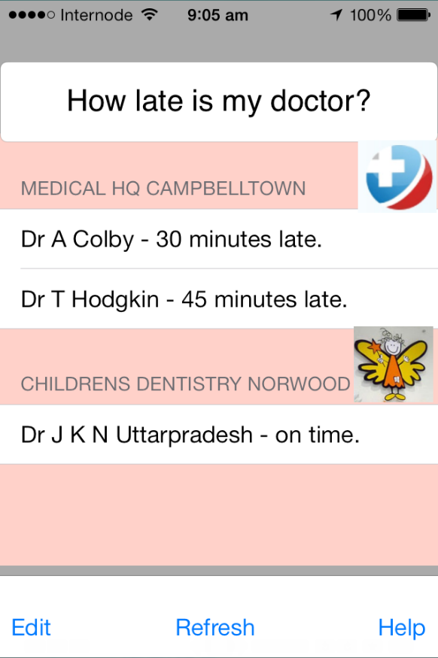

The main page shown has three identifiable views:

* A header text box displaying a phrase like “How late is my doctor”.
* A table view which displays sections. There will be a section for each clinic. The section header will display a logo box for the clinic (set up on the server). This should not have to be downloaded each time. It should be downloaded upon registration of a doctor (see above). Within the clinic will be a list (usually with just one item) of doctors. The item will show the doctor name and the lateness. This string will be formatted at the server.
* A footer view having a refresh button, an edit button and a help button.

### Edit Button

The Edit button should permit a user to delete the doctor entries or add new ones. This should make the delete button appear on the side of each doctor entry. The group header should have a grip (not shown in the mockup) to permit it the group to be dragged up or down. If this is too difficult, advise and this requirement can be omitted.

A new table row should be added to the end of the table showing a PLUS button indicating that a new doctor can be added. Pressing this (+) will seque to a modal view (described below) to register for an additional doctor.

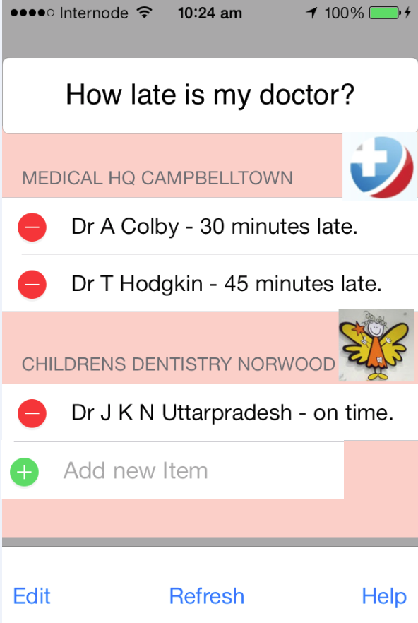

### Register View

This shall be a modal view which will simply permit the user to enter a PIN. There will be no PIN validation. The API call will be made. If an error is returned, then this will be displayed (ensure this error behaviour is tested). If the PIN is valid, then the modal window is closed, and the main window is re-displayed with the new information suitably updated.

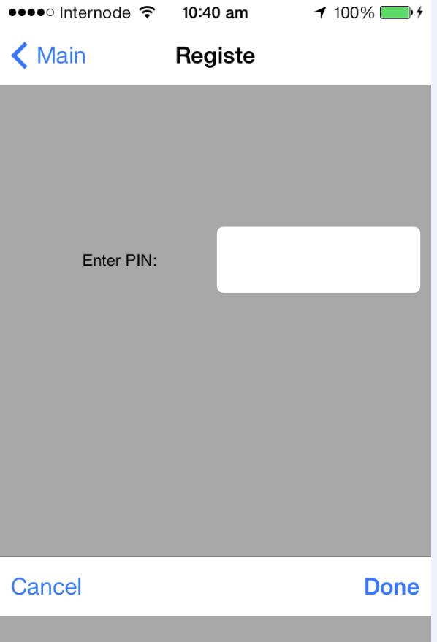

As you can see I need some input with respect to visual design to make it look attractive.

### Refresh Button

This will simply make the API call as described and display the latest results.

### Help Button

The Help button action will be to make the API call (as above) and display a simple modal view with the returned html from the server.

## The Details view

A single tap on a doctor line from the main table view will segue to a modal view showing additional details for the doctor in question. The cached information from last time will be displayed. An API call will be made asynchronously in another thread and the latest results displayed when available. Right now ensure we can retrieve the name jpg and Last-updated information.

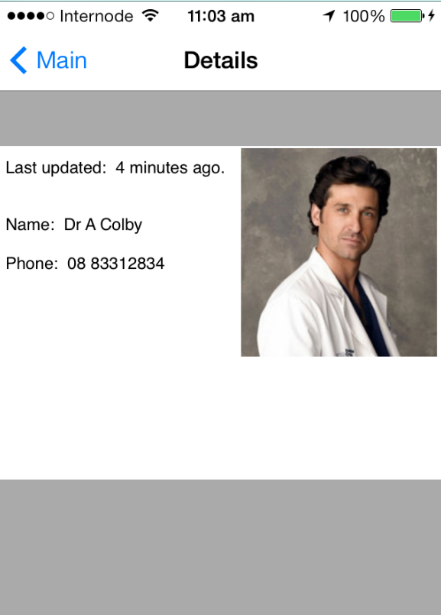

# Special Considerations

Caching. It is important that as much information as possible is visible instantly. The main page should display as it did last time, with a progress indicator signalling that an update is pending.

Looking further ahead, nice-to-have features would include the ability to tap on the clinic header and bring up details. These should include a phone number which can be tapped to dial. Also a